**CVD SYSTEM: LEAK TEST REPORT**

**(July 15 & July 16 2018)**

**(**20180715_184822.csv & 20180716_114209.csv) (Leak test 1 & Leak Test 2.py)

**TEST 1:** A leak test was conducted with the following steps:  
  
1. Evacuation & flush for 1 min each-- Twice  
  
2. Pump down for 5 min (0.2 mbar) and then the butterfly valve was closed (basically a vacuum sealed chamber).  
  
3. All zones were heated to 700 C for 30 minutes.  
  
4. Hold at 700 C for 10 minutes.  
  
5. End of Recipe & system was left for natural cooling.  
  
Observations: A reddish brown colored film can be seen on cupper sheet. Dr. Sandeep will be doing XRD for further confirmation.

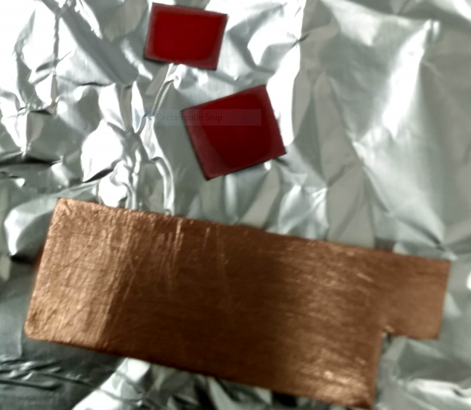 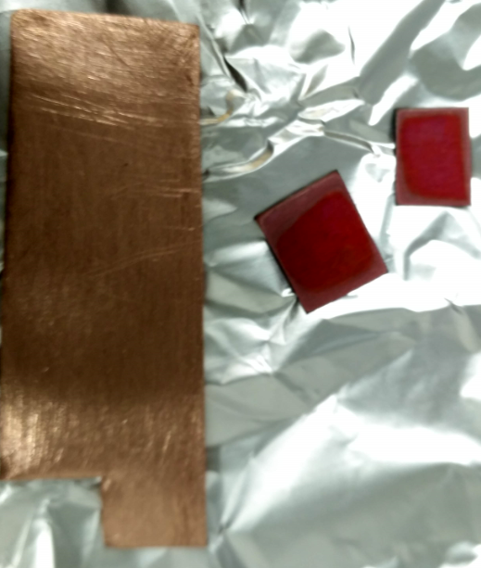

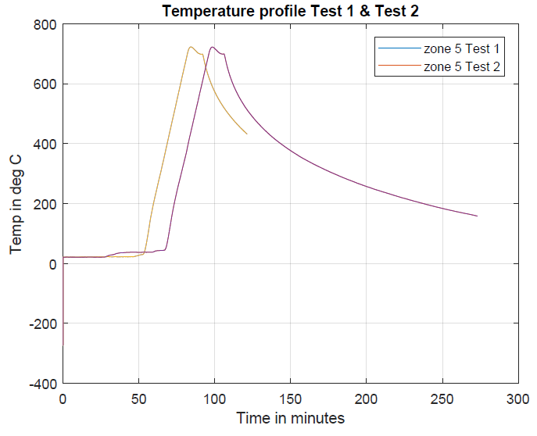

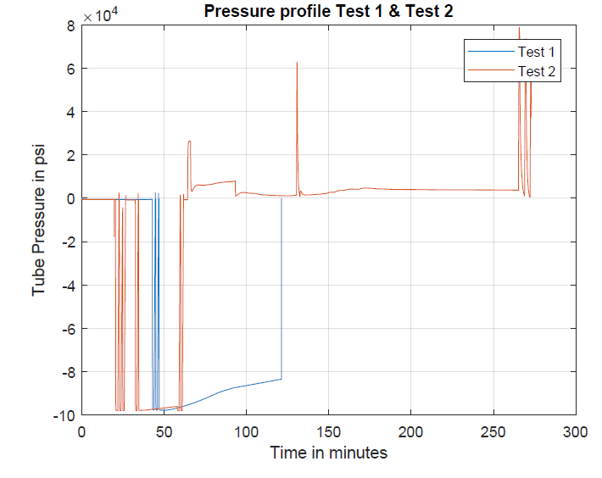

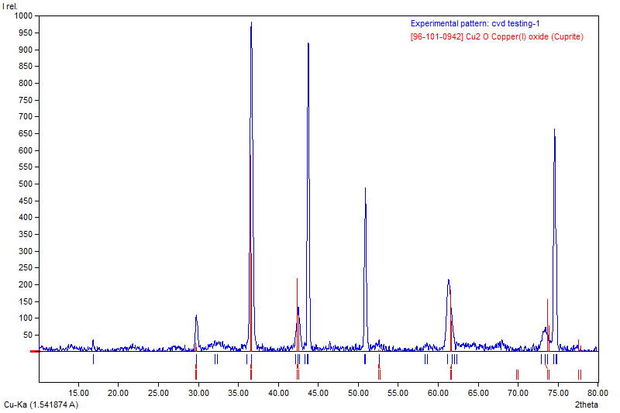

**TEST 2:**  
  
# A second test has been conducted in a nitrogenous environment to compare both the results. The steps are:  
  
1. Evacuation and flush  
  
2. Evacuation for 1 minute  
  
3. Flush for 5 minutes to make a pressure more that atm then gas flow was reduced to 25 sccm and purge valve was opened.  
  
4. All zones were heated to 700 C for 30 minutes and  held for 10 minutes with standard gas flow of 25 sccm.  
  
5. System was left for cooling with a gas flow of 25 sccm.

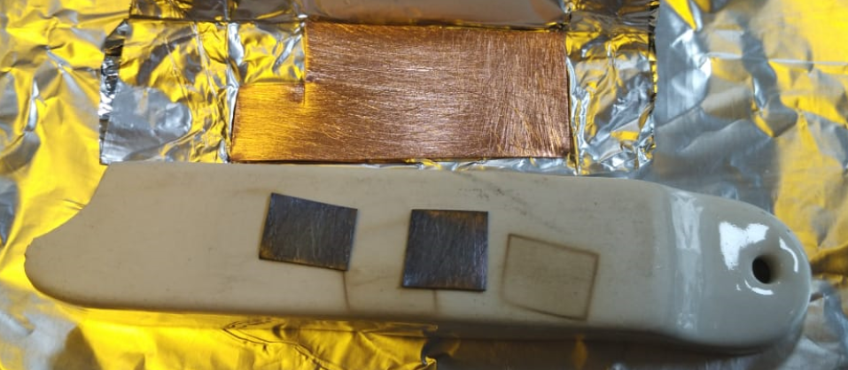 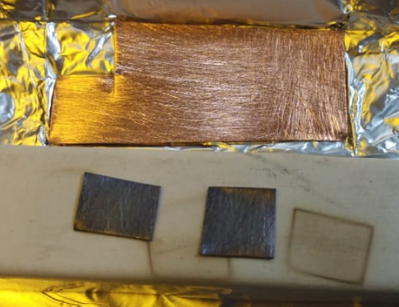  
  
The system will cool down by evening and characterization will be done tomorrow ( XRD).

